**VIVEKANAND EDUCATION SOCIETY’S INSTITUTE OF TECHNOLOGY**

**Department of Computer Engineering**



Project Report on

ULTRASOUND IMAGE ANALYSIS FOR DETECTION OF DOWN SYNDROME

Submitted in partial fulfillment of the requirements of the degree

**BACHELOR OF ENGINEERING** IN **COMPUTER ENGINEERING**

By

**Manan Dadlani D12A/09**

**Ajay Gangwani D12A/15**

**Manish Mulchandani D12A/43**

**Project Mentor**

Mrs. Nusrat Ansari

**University of Mumbai**

**(AY 2023-24)**

**VIVEKANAND EDUCATION SOCIETY’S INSTITUTE OF TECHNOLOGY**

**Department of Computer Engineering**



# CERTIFICATE

This is to certify that the Mini Project entitled **“Ultrasound Image Analysis for detection of down syndrome”** is a bonafide work of **Manan Dadlani(09), Ajay Gangwani(15), Manish Mulchandani(43)** submitted to the University of Mumbai in partial fulfillment of the requirement for the award of the degree of **“Bachelor of Engineering”** in **“Computer Engineering” .**

## (Prof. Mrs. Nusrat Ansari)

Mentor

## (Prof. Dr. Nupur Giri) (Prof. Dr. J.M.Nair)

Head of Department Principal

# Mini Project Approval

This Mini Project entitled “**Ultrasound Image Analysis for detection of down syndrome”** by **Manan Dadlani (09), Ajay Gangwani (15), Manish Mulchandani (43)** is approved for the degree of **Bachelor of Engineering** in **Computer Engineering.**

**Examiners**

**1………………………………………**

(Internal Examiner Name & Sign)

## 2…………………………………………

## (External Examiner name & Sign)

Date: Place:

**Declaration**

We declare that this written submission represents our ideas in our own words and where others' ideas or words have been included, we have adequately cited and referenced the original sources. We also declare that we have adhered to all principles of academic honesty and integrity and have not misrepresented or fabricated or falsified any idea/data/fact/source in our submission. We understand that any violation of the above will be cause for disciplinary action by the Institute and can also evoke penal action from the sources which have thus not been properly cited or from whom proper permission has not been taken when needed.

|  |  |
| --- | --- |
| Manan Dadlani (D12A - 09) | Ajay Gangwani (D12A - 15) |
| Manish Mulchandani (D12A - 43) |  |

Date:

**ACKNOWLEDGEMENT**

We are thankful to our college Vivekanand Education Society’s Institute of Technology for considering our project and extending help at all stages needed during our work of collecting information regarding the project.

It gives us immense pleasure to express our deep and sincere gratitude to Assistant Professor **Mrs. Priya R.L** (Project Guide) for her kind help and valuable advice during the development of project synopsis and for her guidance and suggestions.

We are deeply indebted to Head of the Computer Department **Dr.(Mrs.) Nupur Giri** and our Principal **Dr. (Mrs.) J.M. Nair ,** for giving us this valuable opportunity to do this project.

We express our hearty thanks to them for their assistance without which it would have been difficult in finishing this project synopsis and project review successfully.

We convey our deep sense of gratitude to all teaching and non-teaching staff for their constant encouragement, support and selfless help throughout the project work. It is great pleasure to acknowledge the help and suggestion, which we received from the Department of Computer Engineering.

We wish to express our profound thanks to all those who helped us in gathering information about the project. Our families too have provided moral support and encouragement several times.

**Index**

## Abstract 9

**List of Figures 10**

## Chapter 1: Introduction 11

## 1.1 Introduction 11

## 1.2 Motivation 11

## 1.3 Problem Definition 12

## 1.4 Existing Systems 12

## 1.5 Lacuna of the existing systems 13

## 1.6 Relevance of the Project 14

## Chapter 2: Literature Survey 15

## A. Brief Overview of Literature Survey 15

## B. Related Works 16

## 2.1 Research Papers Referred 16

## 2.2 Patent search 22

## 2.3. Inference drawn 23

## 2.4 Comparison with the existing system 23

## Chapter 3: Requirement Gathering for the Proposed System 24

## 3.1 Introduction to requirement gathering 24

## 3.2 Functional Requirements 25

## 3.3 Non-Functional Requirements 27

## 3.4.Hardware, Software , Technology and tools utilized 28

## 3.5 Constraints 29

## 

## Chapter 4: Proposed Design 30

## 4.1 Block diagram of the system 30

## 4.2 Modular design of the system 30

## 4.3 Detailed Design 31

## 

## Chapter 5: Implementation of the Proposed System 32

## 5.1. Methodology employed for development 32

## 5.2 Algorithms and flowcharts for the respective modules developed 32

## 5.3 Datasets source and utilization 33

## Chapter 6: Testing of the Proposed System 34

## 6.1. Introduction to testing 34

## 6.2. Types of tests Considered 35

## 6.3 Various test case scenarios considered 35

## 6.4. Inference drawn from the test cases 36

## Chapter 7: Results and Discussion 37

## 7.1. Screenshots of User Interface (UI) for the respective module 37

## 7.2. Performance Evaluation measures 38

## 7.3. Input Parameters / Features considered 38

## 7.4. Graphical and statistical output 38

## 7.5. Comparison of results with existing systems 39

## 7.6. Inference drawn 39

## 

## 

## Chapter 8: Conclusion 40

## 8.1 Limitations 40

## 8.2 Conclusion 40

## 8.3 Future Scope 40

## References 42

## Appendix 43

## 1. Competition certificates from the Industry (if any) 43

## 

**Abstract**

Down syndrome (DS), also known as trisomy 21, is one of the most common chromosomal disorders, affecting approximately 1 in 700 live births. This study aims to explore the correctness and accuracy using ultrasound imaging techniques for identifying Down syndrome. Utilizing advanced computer vision and machine learning techniques, the system aims to identify specific brain markers associated with Down syndrome from fetal brain images obtained through prenatal imaging. The research adopts a wide approach, involving data collection, preprocessing, and algorithm development. A diverse dataset is compiled containing both normal and Down syndrome cases, and interpreted for supervised training. Customized Convolutional Neural Networks (CNNs) are developed to effectively extract the features from fetal brain images. The successful implementation of the proposed solution promises to transform prenatal care, offering a reliable and accurate screening tool for early Down syndrome detection. Doctors can upload the ultrasound images of the unborn children to this app and a machine learning algorithm (CNN in our case) would determine whether or not the child has Down syndrome. By empowering healthcare professionals to make informed decisions, this research contributes to improved health outcomes for affected individuals and their families.

## List of figures

|  |  |  |
| --- | --- | --- |
| **Sr no.** | **Figure name** | **Page no.** |
| 1 | Block diagram | 30 |
| 2 | Modular diagram | 30 |
| 3 | Detailed design | 31 |
| 4 | Flow chart | 33 |
| 5 | User Interface (UI) | 37 |
| 6 | Graphical and Statistical output | 38 |

## 

## 

## 

## 

## 

## 

## 

## Chapter 1: Introduction

**1.1 Introduction**

Down syndrome is a condition that impacts both the physical and cognitive development of individuals. It occurs when there is a copy of chromosome 21 leading to health challenges. Identifying Down syndrome in fetuses, at an early stage, is crucial for medical intervention and effective management. Currently invasive techniques like amniocentesis and chorionic villus sampling are used to diagnose Down syndrome during pregnancy. However these procedures carry risks such as miscarriage and other complications. Non-invasive methods, like ultrasound imaging have been explored for screening Down syndrome before birth. In our project we propose a machine learning based approach that utilizes ultrasound images of the brain to detect Down syndrome in fetuses.

The suggested method involves using learning algorithms to examine the characteristics of the unborn baby and detect any irregularities that might indicate Down syndrome. This method has undergone testing on a collection of ultrasound images and has demonstrated promising outcomes. It should be capable of categorizing fetuses as either having or not having Down syndrome based on their features. Moreover this approach is designed to be non-invasive safe and, without posing any risks to both the mother and the baby. Additionally it is expected to be computationally efficient and scalable enough to handle amounts of data.

**1.2 Motivation**

The main motivation behind this project is the need to transform prenatal care by offering a non invasive and ethical method of identifying Down syndrome in fetuses using 3D ultrasound images. Traditional diagnostic approaches can be invasive and come with risks so it is crucial to explore options. Through the utilization of advanced machine learning algorithms and groundbreaking ultrasound technology this project aims to enhance the accuracy of detection making it more accessible for a range of people and reducing long term healthcare expenses. Ultimately the success of this project would empower expecting parents with information allowing them to make decisions about their pregnancy and ensuring timely access to necessary medical services and support. This would greatly improve the quality of life for individuals, with Down syndrome as their families.

**1.3 Problem Definition**

Down syndrome is a condition that affects a large number of people due to a genetic disorder. It occurs when there is an extra chromosome 21 leading to health complications. Detecting Down syndrome in fetuses at a prenatal stage is crucial for medical intervention and better management of the condition. Currently invasive methods like amniocentesis and chorionic villus sampling are used to diagnose Down syndrome during pregnancy. However these procedures come with risks such as miscarriage and other complications. To address this researchers have explored invasive techniques like ultrasound imaging, for prenatal screening of Down syndrome. Unfortunately the existing methods are not always accurate. It can result in false positives or false negatives. In this project we propose a machine learning based approach that utilizes ultrasound images of the brain to detect Down syndrome in fetuses. Our goal is to classify whether fetuses have or do not have Down syndrome based on the features of their brain while ensuring the safety and well being of both the mother and the fetus throughout the process.

**1.4 Existing Systems**

There are currently two main approaches for Down syndrome detection in fetuses:

1. **Invasive Prenatal Diagnosis:**

* **Amniocentesis:** This is when a sample of the amniotic flotation around the fetus is obtained through the mother's abdomen with a needle. The fluid contains cells from the baby that can be examined to see if it has correct chromosomes, or if there might be any malformations such as Down's Syndrome. Although highly accurate (over 99%) for diagnosis, amniocentesis is a slightly dangerous procedure: chances of causing miscarriage are around 0.5%.
* **Chorionic villus sampling (CVS):** At this stage, the fetal membrane is not fully developed so a long tube is inserted into mother's vagina and then through a small opening in her cervix (the lower part of womb) and up against chorionic villi (cells on grape-like clusters) which hang from placenta wall very close to amniotic sac, taking out parts of villi for analysis. It may be done sooner than amniocentesis but it carries an even higher risk of miscarriage (approximately 1%).

2. **Non-invasive Prenatal Screening:**

* **Combining First Trimester screening:** Test involves the mother's age, a blood test to measure specific hormones during pregnancy, and the doctor performing an ultrasound scan of Nuchal Translucency (NT) measurement on baby's neck, which together determine chances for developing Down Syndrome. Although it is non-invasive but after all, with lower detection rates (about 80-85%) as well as greater false-positives (approximately 5%).
* **Cell-Free Fetal DNA (cffDNA) Testing:** This century-old technique processes fragments from fetal DNA circulating in a woman's body. Its detection rate is higher (over 99%) and the rate of false-positives is lower (2-3%) than prenatal screening that combines the first trimester. However, it's more expensive and not routinely offered in all prenatal care settings.

**1.5 Lacuna of the Existing Systems**

1. Invasive Prenatal Diagnosis:

* **Miscarriage:** A small but real risk of miscarriage goes with both amniocentesis and chorionic villus sampling (CVS). The unpredictable nature of these tests may deter expectant parents from choosing it for their baby, particularly when that fetus is not at high risk for Down's syndrome to begin with.
* **Early identification of problems:** Amniocentesis and CVS are procedures carried out later in a pregnancy. This delays the diagnosis and therefore eliminates or limits what methods might be taken to intervene medically or stop the fetal heart, if that is what parents want.
* **Accessibility and cost:** These procedures are expensive and may not be available to pregnant women or pregnant people in general without proper care--especially when it's an unusual location such as a resource-limited setting where adequate health insurance coverage isn't available for everyone.

2. Non-Invasive Prenatal Screening (NIPS):

* **Detection Rates:** First-trimester screening and cell-free fetal DNA testing have eased the differences between non-invasive and invasive, but may reduce detection rate. This missing diagnosis yields a discussed impact for all NIPS results and babies is our profound anxiety.
* **False-Positive Rates:** Given the higher rates of false positives with non-invasive tests, especially in first-trimester screening, fear may be unjustly fed; when patients do not need invasive follow-up operations on their own bodies.
* **Cost and Accessibility:** However, cffDNA testing offers lower false-positive rates and higher detection rates, than do the traditional first-trimester screens. This test is also more expensive though so it could not be part of regular prenatal care in many places. The cost thus becomes a barrier.

**1.6 Relevance of the Project**

This project is important because what it aims at is to revolutionize prenatal care for women by providing them with a non-invasive way of identifying Down's syndrome in their fetuses using ultrasound images. It can predict with a machine learning algorithm and no need for invasive surgery in advance for precise diagnosis, providing anticipating parents with valuable information to help them make decisions. Not only is this approach safer and more convenient, it may also lower long-term health care costs in addition to promoting the overall welfare of people with Down Syndrome and their families.

## Chapter 2: Literature Survey

**A.** **Brief Overview of Literature Survey**

In this literature survey, various image analysis methodologies and machine learning-based systems have been explored for the purpose of detecting the Down syndrome of the fetus with ultrasound of the fetus’s brain. Research studies have been conducted that implemented distinct image analysis techniques and learning-based algorithms to develop more accurate and efficient screening. These researches have presented significant progress in getting the analysis of ultrasound images from conventional image processing methodologies to sophisticated deep learning structures. However, one of the notable deficiencies in research studies is the lack of exploration in analysis methodologies related to a few segmentation or other specific techniques. This survey reflects these deficiencies and indicates the requirement of novel methodologies to command it towards specificity and granularity.

To bridge this gap, our project offers a new approach to the classification of ultrasound fetal brain images in three independent planes: trans thalamic, trans cerebellum, and trans ventricles. Once the segmentation is complete, a more thorough and detailed analysis may help enhance Down syndrome detection accuracy. An advanced machine learning algorithm and a newer, improved classification strategy will allow us to reform prenatal care and provide medical professionals with more accurate, reliable, and easy-to-understand information. At the same time, our primary target is to offer prospective parents a more meaningful, reliable, and timely opportunity to know more about the pregnancy, to determine the best strategies to support their baby’s health, and to understand and cope with the challenges related to a Down syndrome diagnosis.

**B.** **Related Works**

**2.1 Research Papers Referred**

[1] **Automatic Fetal Facial Expression Recognition by Hybridizing Saliency Maps with Recurrent Neural Network (2019)**

* **Abstract:** This study introduces a method for fetal facial expression recognition by combining saliency maps and recurrent neural networks. Despite a small dataset of 40 images, the approach aims to address challenges in analyzing fetal expressions. However, potential limitations include noise, occlusion, and variations in image quality.
* **Inference:** The integration of saliency maps and recurrent neural networks offers promise for accurately detecting fetal facial expressions. Challenges such as noise and occlusion may impact performance, necessitating further evaluation on larger datasets. Refinement of the approach could enhance its effectiveness in clinical applications.

[2] **Automatic recognition of fetal facial ultrasound standard planes based on improved YOLOv4 (2022)**

* **Abstract:** The paper presents a lightweight target detection network using YOLOv4 with GhostNet to identify fetal facial ultrasound standard planes, aiming to overcome limitations of manual approaches. Despite a relatively small dataset of 1,200 images, the model successfully automates identification of key anatomical structures within fetal ultrasound images. However, challenges including occlusion, deformation, and abnormalities in fetal faces need to be addressed.
* **Inference:** The integration of YOLOv4 with GhostNet offers a promising solution for automatically recognizing fetal facial ultrasound standard planes, potentially revolutionizing prenatal imaging. Despite computational demands, the model shows efficiency in identifying key anatomical structures. Further research should focus on mitigating challenges such as occlusion and abnormalities to enhance the model's applicability in clinical settings.

[3] **Computer-aided diagnosis for fetal brain ultrasound images using deep convolutional neural networks (2020)**

* **Abstract:** This study introduces computer-aided diagnosis algorithms using convolutional neural networks (CNNs) to detect five common fetal brain abnormalities from ultrasound images, aiming to assist doctors in prenatal neuro sonographic assessment. The proposed method achieves promising results, including a Dice score of 0.942 for craniocerebral region segmentation, an average F1-score of 0.96 for classification, and an average mean IOU of 0.497 for lesion localization. However, the dataset size of 1,200 images is relatively small, and challenges such as limited coverage of variations and complex abnormalities need to be addressed.
* **Inference:** The utilization of CNNs for computer-aided diagnosis of fetal brain abnormalities shows considerable potential for enhancing prenatal neuro sonographic assessment. Despite achieving an accuracy of approximately 96%, further research is needed to address challenges related to dataset size limitations and the complexity of abnormalities. Improving accuracy and robustness would increase the applicability of the proposed method in clinical settings, particularly for highly precise diagnostic tasks.

[4] **Deep Learning Based Fetal Face Detection And Visualisation Prenatal Ultrasound**

**(2021)**

* **Abstract:** This paper introduces a novel approach for fetal face detection and visualization using 3D ultrasound volumes, employing deep learning techniques. The method incorporates a 3D CNN for detection, a 3D U-Net for segmentation, and 3D rendering for visualization, aiming to address challenges in training deep learning networks for fetal face tasks. Despite challenges such as handling low-quality or noisy ultrasound volumes and managing variations in fetal face orientation, pose, and expression, the approach achieves robust and accurate results.
* **Inference:** The utilization of deep learning for fetal face detection and visualization presents a promising solution for analyzing prenatal ultrasound data. By integrating 3D CNNs and U-Nets, the method demonstrates effectiveness in generating segmentation networks for dual purposes. However, challenges such as handling low-quality or noisy ultrasound volumes and managing variations in fetal face orientation and expression need to be addressed to enhance detection and segmentation accuracy. Further research is warranted to refine the approach for improved clinical applications.

[5] **Fetal Facial Expression Recognition System by Lip Distance Method (2023)**

* **Abstract:** This paper introduces a system for classifying fetal facial expressions using the lip distance method, aiming to distinguish between normal and abnormal fetal behaviors. The algorithm extracts the fetal lip region and measures upper and lower lip distances based on landmark points from eyes, nose, and lips, enabling classification of expressions such as neutral, smile, cry, and yawn. Despite challenges such as high complexity, noise amplification, and dependency on image size, the proposed model demonstrates the ability to analyze fetal expressions from 4D scans, showing developmental milestones in facial expressions over gestational weeks.
* **Inference:** The implementation of the lip distance method for fetal facial expression recognition offers a novel approach to understanding prenatal behavior. Despite challenges including complexity and noise amplification, the system provides valuable insights into fetal development, showcasing milestones in facial expressions. However, further refinement is necessary to address difficulties in image selection and improve robustness across varying image sizes, enhancing the system's applicability in clinical settings for identifying abnormal fetal behaviors.

[6] **Deep Learning-Based Methodology for Recognition of Fetal Brain Standard Scan Planes in 2D Ultrasound Images (2019)**

* **Abstract:** This paper introduces two deep convolutional neural network (CNN) based methodologies for automatically recognizing six standard planes of fetal brains from 2D ultrasound images. Utilizing both a deep CNN and CNN-based domain transfer learning, the methods aim to address challenges in recognizing fetal brain standard planes. Despite limitations such as lack of qualitative analysis and discussion on challenges such as variability and complexity in ultrasound images, the novel deep CNN-based approach demonstrates automatic recognition of fetal brain standard planes, with image transformation and domain transfer learning mitigating overfitting and improving performance.
* **Inference:** The deployment of deep CNN-based methodologies for recognizing fetal brain standard planes presents a significant advancement in prenatal imaging. While the novel approach successfully addresses overfitting issues and improves recognition performance, there are notable limitations such as the absence of qualitative analysis and discussion on challenges in fetal brain plane recognition. Further research should focus on addressing these limitations to enhance the applicability and reliability of the proposed methodologies in clinical settings.

[7] **Deep Hybrid Learning Method for Classification of Fetal Brain Abnormalities (2021)**

* **Abstract:** This paper introduces a deep hybrid learning method for classifying fetal brain abnormalities in 2D ultrasound images, combining convolutional neural networks (CNNs) for feature extraction and support vector machines (SVMs) for classification. The proposed method outperforms individual CNNs or SVMs, achieving higher accuracy compared to other methods. However, the model is trained on data from a single hospital, highlighting the need for future research to evaluate its performance with diverse ultrasound datasets from multiple hospitals.
* **Inference:** The integration of CNNs and SVMs in a deep hybrid learning method offers a promising approach for classifying fetal brain abnormalities from ultrasound images. Despite demonstrating superior performance, the method's reliance on data from a single hospital underscores the importance of assessing its robustness with diverse datasets. Future research should prioritize evaluation with ultrasound data from multiple hospitals to ensure the method's generalizability and effectiveness in clinical settings.

[8] **A Review on Deep-Learning Algorithms for Fetal Ultrasound-Image Analysis (2021)**

* **Abstract:** This paper presents a comprehensive review of deep learning algorithms utilized in the analysis of fetal ultrasound images, focusing on standard-plane detection, anatomical structure analysis, and biometry parameter estimation. It discusses the latest advancements in deep learning techniques for fetal ultrasound image analysis, providing insights into current methodologies and their applications. However, challenges such as insufficient high-quality annotated datasets and potential imbalance in representation due to rapid advancements in deep learning techniques are highlighted, emphasizing the need for further research to address these issues.
* **Inference:** The review of deep learning algorithms for fetal ultrasound image analysis offers valuable insights into the state-of-the-art methodologies and applications. Despite the significant progress, challenges such as dataset quality and representation imbalance remain unresolved. Future research efforts should prioritize the development of high-quality annotated datasets and ensure balanced representation across different deep learning techniques to improve algorithm evaluation and generalizability in clinical practice.

[9] **An Intelligent Method for Down Syndrome Detection in Fetuses Using Ultrasound Images and Deep Learning Neural Networks (2021)**

* **Abstract:** This paper introduces an intelligent method for detecting Down syndrome in fetuses using ultrasound images and deep learning neural networks, specifically convolutional neural networks (CNNs). The approach involves processing ultrasound images through a deep neural network (DNN) to extract features for classifying the images as normal or abnormal. Evaluation results indicate that the proposed method effectively identifies fetuses with Down syndrome using ultrasound scans. However, challenges such as insufficient training data are noted, suggesting the need for further research to address these limitations.
* **Inference:** The proposed intelligent method for Down syndrome detection in fetuses demonstrates promising results by leveraging deep learning neural networks and ultrasound images. Despite its success, challenges such as limited training data remain, highlighting the importance of expanding datasets for more robust and reliable detection models. Future research should focus on overcoming these challenges to enhance the method's accuracy and applicability in clinical settings.

[10] **A Deep Convolutional Neural Network-Based Framework for Automatic Fetal Facial Standard Plane Recognition (2018)**

* **Abstract:** This paper presents a framework for automatic recognition of fetal facial standard planes (FFSP) using a deep convolutional neural network (DCNN) architecture, aimed at improving recognition performance. The model, inspired by VGGNet, consists of sixteen convolutional layers and three fully connected layers. Architecture optimization, data augmentation, and fine-tuning strategies are employed to enhance recognition performance. However, challenges such as insufficiency of training data, data imbalance, and low sample rate for non-FFSP sub-images are identified, indicating areas for further improvement.
* **Inference:** The proposed deep convolutional neural network framework for automatic FFSP recognition demonstrates promising performance enhancements through architecture optimization and training strategies. However, challenges including limited training data, data imbalance, and low sample rates for non-FFSP sub-images pose obstacles to further improving recognition accuracy. Future research should focus on addressing these challenges to enhance the framework's effectiveness in clinical applications.

[11] **Toward deep observation: A systematic survey on artificial intelligence techniques to monitor fetus via ultrasound images (2022)**

* **Abstract:** This paper conducts a systematic survey of artificial intelligence (AI) techniques utilized in monitoring the fetus via ultrasound images, covering various applications including fetal growth monitoring, anomaly diagnosis, and health risk assessment. Focused on research employing ultrasound imaging and AI systems, the study highlights the potential of AI to enhance fetal monitoring by enabling early abnormality detection and personalized care for pregnant mothers. However, limitations such as the restriction to English-language papers and the rapid development in AI affecting evaluation accuracy are acknowledged, suggesting avenues for future research.
* **Inference:** The systematic survey of AI techniques for fetal monitoring via ultrasound images underscores the significant potential of AI in improving prenatal care. Despite the acknowledgment of limitations such as language restrictions and rapid AI development, the study highlights the transformative impact of AI in enabling early diagnosis and personalized care for pregnant women. Future research efforts should address these limitations to further enhance the accuracy and effectiveness of AI-based fetal monitoring systems.

**2.2 Patent Search**

**Introduction:**

As part of our project to develop an ultrasound analysis system for detecting Down syndrome in fetal brain imaging, we conducted a thorough patent search. This was essential to ensure our innovations are novel and do not infringe upon existing intellectual property rights.

**Methodology:**

We utilized patent databases like Google Patents, employing tailored keywords and criteria to refine our search. Filters such as publication date and patent classification codes were applied to focus on relevant patents.

**Findings:**

Our search yielded a list of relevant patents, providing insights into ultrasound imaging techniques, medical diagnostics, and image analysis algorithms. We identified patents that may impact our system's development and assessed the novelty of our technology.

**Analysis:**

Analysis of the identified patents revealed potential obstacles and constraints. We evaluated the uniqueness of our technology and its patentability in comparison to existing patents.

**Conclusion:**

The search findings will guide our project's next steps, informing research, development, and patent filing processes. We will consider licensing agreements and conduct further searches to navigate the intellectual property landscape effectively.

**Future Considerations:**

Moving forward, we'll explore collaborations with patent holders and continue monitoring the patent landscape to safeguard our system's innovations.

**2.3 Inference Drawn**

The analysis of fetal ultrasound images using deep learning is becoming more common, according to the literature review.The focus is on fetal brain defect identification, standard fetal scan plane detection, and automatically detecting the fetal facial expression. Recurrent neural networks, YOLOv4, and convolutional neural networks are being employed to address this problem, according to the literature review research.Additionally, there is a growing focus on creating systems for specific uses, like detecting Down syndrome and displaying the fetus's face. The examination of the literature review also suggests that the emphasis will be on learning strategies and distinctive traits like lip distance to interpret facial expressions.In conclusion, the assessment of the literature provides strong evidence of the significance of AI in raising the precision and efficacy of fetal monitoring through ultrasound images.

**2.4 Comparison with the Existing Systems**

In contrast, the ultrasound images of the brain instead have been used to detect Down syndrome in fetuses. Our approach offers several advantages over existing methods. Firstly, it provides a non-invasive alternative to traditional invasive prenatal diagnosis: amniocentesis and chorionic villus sampling. This eliminates risks associated with these procedures such as miscarriage. Secondly, although non-invasive screening methods such as first-trimester screening and cffDNA testing have high detection rates, our approach aims to offer comparable or potentially improved accuracy by examining ultrasound images for some subtle abnormalities associated with Down syndrome.

Furthermore, our approach may be a more cost-efficient and broadly available option for the patients compared to cffDNA testing, which cost includes expenses and does not involve routine examination in some prenatal care environments. What is more, due to the application of sophisticated machine learning algorithms, our model would aim to reduce the risks of incorrect monitoring and inform parents of the diagnostics more consistently. Finally, our method would be more advantageous in terms of timing and utilization since it can be used at early stages in the absence of immediate-inviting intervention, allowing quicker and accessible-permission screening. Consequently, our machine learning variant has the potential to become a more accurate, available, and comfortable screen with minor intervention risks.

**Chapter 3: Requirement Gathering for the Proposed System**

**3.1 Introduction to requirement gathering**

The process of requirement gathering plays a crucial role in establishing the foundational elements of any system or solution. It involves a systematic approach to understanding the objectives, constraints, and functionalities necessary for the proposed system. In the context of our project, which focuses on utilizing fetal brain ultrasound analysis for detecting Down syndrome, the requirement gathering phase is pivotal in delineating the specific specifications and features required for an effective diagnostic tool.

**Purpose of Requirement Gathering:**

Requirement gathering serves the fundamental purpose of comprehensively understanding the needs and expectations of stakeholders. This understanding guides subsequent stages of system design, development, and implementation. By engaging stakeholders such as healthcare professionals, researchers, and expectant parents in collaborative discussions, we ensure that the resulting system closely aligns with practical requirements and operational realities in clinical settings.

**Key Objectives:**

* **Identifying User Requirements:** Through interviews, surveys, and consultations, our aim is to elicit specific needs and preferences of end-users, particularly healthcare practitioners who will utilize the ultrasound analysis system for prenatal screening and diagnosis.
* **Defining Functional and Non-Functional Requirements:** We will outline functional requirements, encompassing desired features and capabilities, as well as non-functional requirements such as performance and usability considerations.
* **Addressing Technological Considerations:** Given advancements in ultrasound imaging technology and data analytics, we will explore technical requirements and constraints associated with integrating cutting-edge tools and algorithms into the proposed system.
* **Ensuring Ethical and Regulatory Compliance:** Compliance with ethical guidelines, patient privacy regulations, and medical device standards is integral. This ensures responsible and ethical development of the ultrasound analysis system.

**3.2 Functional Requirements**

**1. Image Acquisition and Processing:**

* The system should possess the capability to capture high-resolution ultrasound images of the fetal brain.
* It should include functionality for real-time image enhancement to improve clarity and minimize interference.
* Adjustability of imaging parameters like gain, depth, and focus should be incorporated for optimizing image quality.

**2. Automated Analysis Algorithms:**

* Integration of algorithms for automated identification and measurement of structural irregularities associated with Down syndrome in fetal brain ultrasound scans.
* Incorporation of features facilitating quantitative analysis of critical biometric parameters, such as biparietal diameter, cerebellar diameter, and nuchal translucency thickness.
* Utilization of machine learning or artificial intelligence algorithms for pattern recognition and anomaly detection.

**3. Diagnostic Decision Support:**

* Provision of tools for diagnostic decision support to aid healthcare professionals in interpreting ultrasound results.
* Automated generation of reports summarizing key findings and indicating the likelihood of Down syndrome based on ultrasound analysis.
* Seamless integration with existing clinical decision support systems to ensure comprehensive patient care.

**4. User Interface and Interaction:**

* Design of an intuitive user interface with streamlined navigation and workflow management.
* Customization options allowing users to adjust settings according to individual preferences.
* Support for integration with other imaging modalities like MRI or genetic testing results for comparative analysis.

**5. Data Management and Integration:**

* Secure storage and management of ultrasound images and patient data in compliance with privacy regulations.
* Seamless integration with electronic health record systems to facilitate data exchange and interoperability.
* Provision of data analysis and research functionalities, including anonymization and aggregation features for large-scale studies.

**6. Quality Assurance and Control:**

* Implementation of quality assurance protocols to ensure the accuracy and reliability of ultrasound imaging and analysis.
* Regular calibration and maintenance procedures to optimize system performance and minimize variations.
* Logging and auditing mechanisms to monitor user interactions and system activities for quality control purposes.

**7. Training and Support:**

* Provision of comprehensive training materials and resources to assist healthcare professionals in effectively utilizing the ultrasound analysis system.
* Ongoing technical support and troubleshooting services to address user queries and concerns promptly.
* Regular updates and enhancements to incorporate technological advancements and emerging clinical practices.

**3.3 Nonfunctional Requirements**

**1. Performance:**

* The system must efficiently process ultrasound images and generate diagnostic reports within acceptable timeframes, supporting seamless clinical workflow.
* It should handle large volumes of image data without performance degradation, ensuring uninterrupted access to critical information.
* User interactions, such as image manipulation and report generation, should be responsive, enhancing overall user experience.

**2. Usability:**

* The user interface should be intuitive and easy to navigate, requiring minimal training for healthcare professionals.
* Clear labeling and consistent design elements should facilitate straightforward navigation and usability.
* Accessibility features should be integrated to cater to users with diverse needs, promoting inclusivity and usability.

**3. Reliability:**

* The system must demonstrate high reliability, minimizing downtime and system failures to ensure continuous access to essential functions and data.
* Robust error handling mechanisms should quickly detect and resolve issues, preventing data loss or corruption.

**4. Security:**

* Patient data must be encrypted and protected from unauthorized access to maintain confidentiality and comply with privacy regulations.
* Role-based access controls should restrict system functionalities and data access according to user permissions.
* Comprehensive logging and auditing features should track user activities and system events for accountability and compliance.

**5. Scalability:**

* The system should be designed to accommodate future growth and increased user demand, supporting scalability through modular design and scalable infrastructure components.
* Seamless upgrades and enhancements should be facilitated to meet evolving needs and technological advancements.

**6. Regulatory Compliance:**

* Compliance with relevant regulatory requirements and standards for medical devices and healthcare IT systems is imperative, including adherence to FDA regulations and ISO standards.
* Regular assessments and audits should ensure ongoing compliance and adherence to industry best practices.

**7. Maintainability:**

* Modular design and code maintainability should facilitate efficient troubleshooting, updates, and enhancements.
* Comprehensive and up-to-date documentation should provide clear guidance for system maintenance and software development tasks.

**3.4 Hardware, Software, Technology and Tools Utilized**

**For frontend and backend:**

* Flutter for UI Development.
* Flask for Backend Development.
* NodeJS for API.

**For Image Processing and Analysis:**

* OpenCV (Open Source Computer Vision Library).
* CNN model (Deep learning algorithm for training the model).
* Deep Learning Frameworks (e.g., TensorFlow, PyTorch and keras for model building).

**Data Storage and Management:**

* DynamoDB (AWS service for more secure storage).

**For security and authentication:**

* Cognito (and other AWS services like IAM, etc for more secure log in)

**3.5 Constraints**

1. **Technological Constraints:**The development of the proposed system is subject to certain technological constraints. These include compatibility issues with legacy systems, limitations imposed by the selected software platforms, and hardware infrastructure constraints. Ensuring seamless integration with existing technology stacks and addressing compatibility challenges will be crucial for the success of the project.

2. **Regulatory Constraints:**Compliance with regulatory requirements, such as data privacy regulations and industry standards, is imperative for the proposed system. Adhering to regulatory constraints will necessitate robust data handling protocols, stringent security measures, and regular compliance audits to ensure adherence to relevant regulations and guidelines.

3. **User Constraints:**User preferences, expectations, and limitations will influence system design and usability. Addressing user accessibility requirements, language preferences, and usability constraints will be essential to ensure user satisfaction and acceptance of the system.

**Chapter 4: Proposed Design**

**4.1 Block diagram of the system**

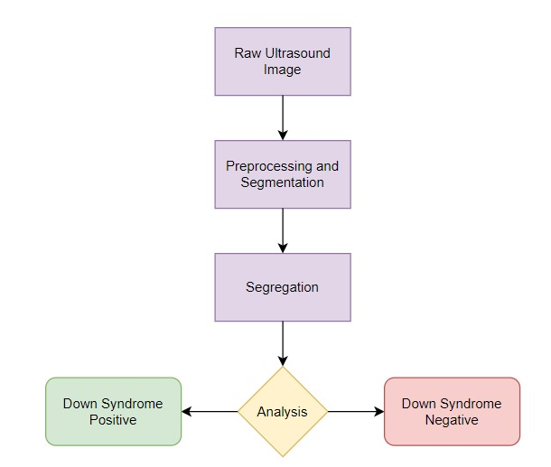

**Fig 1: Block diagram of the system**

**4.2 Modular design of the system**

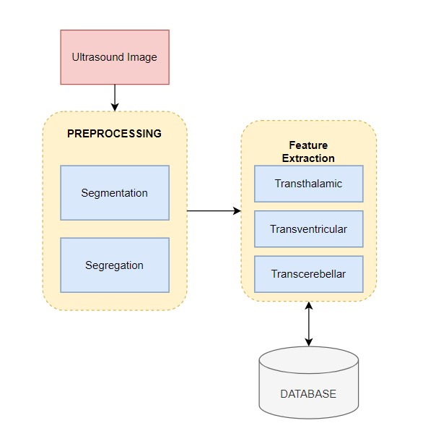

**Fig 2: Modular design of the system**

**4.3 Detailed Design**

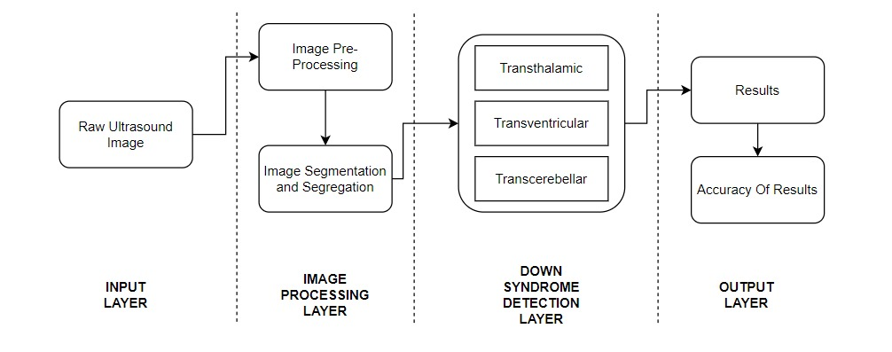

**Fig 3: Detailed design of the system**

**Chapter 5: Implementation of the Proposed System**

**5.1. Methodology employed for development**

Developing ultrasound image analysis for detecting Down syndrome typically involves several key steps and methodologies:

* **Data Collection:** Gather a large dataset of ultrasound images of fetuses, including both normal cases and cases with Down syndrome. These images should cover a range of gestational ages and imaging conditions.
* **Preprocessing:** Clean the ultrasound images to remove noise, artifacts, and irrelevant information. This may involve techniques such as image smoothing, filtering, and normalization to ensure consistency and quality across the dataset.
* **Feature Extraction:** Identify relevant features from the preprocessed images that may distinguish between normal and Down syndrome cases. Features could include measurements of various anatomical structures, texture features, and other image characteristics.
* **Model Development:** Choose an appropriate machine learning model for classification based on the selected features.
* **Model Training:** Train the selected model using the annotated dataset of ultrasound images. This involves optimizing the model's parameters to minimize classification errors and maximize predictive accuracy.

**5.2 Algorithms and flowcharts for the respective modules developed  
  
Algorithm:**

* **Convolutional Layers:** Extracts hierarchical features using learnable filters.
* **Pooling Layers:** Downsamples feature maps, retaining important features.
* **Flattening:** Converts the final feature map into a one-dimensional vector.
* **Fully Connected Layers:** Connects the flattened vector to fully connected layers for classification.
* **Output Layer:** Utilizes softmax activation to generate class probabilities (normal/abnormal).
* **Training Procedure:** Uses labeled dataset for training, adjusting model parameters to minimize errors.
* **Inference:** Feeds input images to the trained model, obtaining classification predictions.

**Flowchart:**

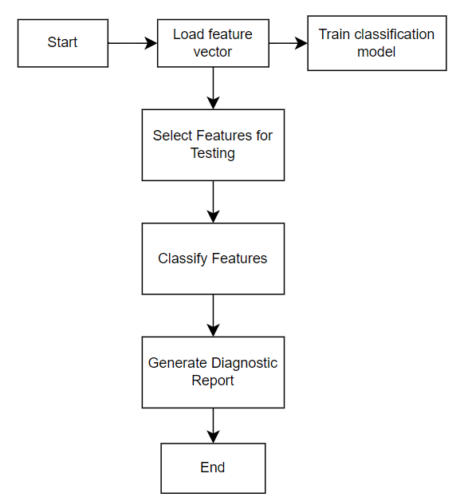

**Fig 4: Flowchart of the System**

**5.3 Datasets source and utilization**

1. **Dataset Source:**  
   The datasets utilized in this project were sourced from Zenodo, a renowned platform for sharing research data. Zenodo offers a diverse collection of open-access datasets contributed by researchers worldwide, ensuring data quality and reliability.
2. **Dataset Utilization:**The datasets sourced from Zenodo played a pivotal role in training, validating, and testing the ultrasound analysis system. The images were divided into training, validation, and test sets, with a 70-15-15 split, respectively. Data augmentation techniques, such as rotation, flipping, and scaling, were employed to augment the dataset and increase its diversity. Additionally, preprocessing steps, including normalization and standardization, were applied to ensure consistent data representation and improve model convergence.

**Chapter 6: Testing of the Proposed System**

**6.1. Introduction to testing**

Testing constitutes a pivotal phase in the development lifecycle of any software solution, including the proposed ultrasound analysis system aimed at detecting Down syndrome in fetal brain imaging. This section delineates the methodologies, strategies, and approaches utilized to assess the functionality, performance, and dependability of the proposed system.

**Purpose of Testing:**

At the core of testing lies the objective to validate the accuracy, comprehensiveness, and resilience of the ultrasound analysis system, ensuring its alignment with predefined requirements and its ability to deliver precise diagnostic outcomes. By subjecting the system to rigorous testing protocols, potential flaws, discrepancies, and vulnerabilities can be identified and rectified, thereby elevating the overall quality and reliability of the system.

**Key Objectives:**

* **Functional Verification:** The primary aim is to ascertain that the system operates as intended, adhering to the functional requirements delineated in earlier sections. This entails scrutinizing individual features, modules, and components to ensure their proper implementation and seamless interaction within the system.
* **Performance Evaluation:** The focus is on assessing the system's responsiveness, throughput, and scalability across diverse workload scenarios. Performance testing endeavors to pinpoint bottlenecks, resource limitations, and optimization avenues to augment the system's efficiency and responsiveness.
* **Accuracy and Reliability Testing:** The emphasis lies on evaluating the precision and dependability of diagnostic outcomes produced by the system, particularly concerning the detection of Down syndrome-associated anomalies in fetal brain ultrasound images. This involves juxtaposing the system's outputs against reference data and clinical benchmarks to validate its diagnostic efficacy.
* **Usability Assessment:** The objective is to gauge the system's usability and user experience, scrutinizing factors such as intuitiveness, navigability, and task proficiency. Usability testing encompasses soliciting feedback from end-users and stakeholders to pinpoint usability impediments and areas necessitating refinement.
* **Security and Compliance Testing:** The endeavor involves validating the security measures integrated into the system to safeguard patient data, ensure regulatory adherence, and mitigate potential security lapses. This encompasses conducting vulnerability assessments, penetration testing, and compliance audits to identify and rectify security vulnerabilities and compliance deficiencies.

**6.2. Types of tests Considered**

1. **Unit Tests:** These assessments scrutinized individual components or modules of the system independently to validate their functionality.
2. **Integration Tests:** Verification of the interaction and interoperability of integrated components was conducted to ensure smooth operation.
3. **Performance Testing:** The system's responsiveness, throughput, and scalability were evaluated across varying workload scenarios.
4. **Security Testing:** Identification and mitigation of potential security vulnerabilities were undertaken through comprehensive security testing procedures.
5. **Usability Testing:** The system's ease of use and user experience were assessed to ascertain its suitability for intended users.

**6.3 Various test case scenarios considered**

1. **Description:** Each test case scenario includes a succinct overview of the specific functionality or aspect of the system under examination.
2. **Input Data**: Elucidation of the input data, parameters, or conditions utilized for each test case scenario.
3. **Expected Outcome:** Anticipation of the result or behavior expected from the system when subjected to the test case scenario.
4. **Procedure:** The sequential steps or actions executed to implement the test case scenario, inclusive of any prerequisites or setup.
5. **Actual Outcome:** Documentation of the observed result or behavior of the system during the execution of the test case scenario.

**6.4. Inference drawn from the test cases**

1. **System Strengths:** Identification of areas where the system excelled and met or exceeded expectations.
2. **Areas for Improvement:** Recognition of weaknesses, shortcomings, or areas necessitating further refinement or enhancement.
3. **Performance Insights:** Insights gleaned from the system's performance, scalability, responsiveness, and resource utilization based on the outcomes of the tests.
4. **User Feedback:** Integration of feedback garnered from end-users and stakeholders during user acceptance testing to inform future iterations and enhancements.
5. **Security and Compliance Considerations:** Discussion surrounding any security vulnerabilities, compliance discrepancies, or regulatory concerns unearthed during security and compliance testing.

**Chapter 7: Results and Discussion**

**7.1. Screenshots of User Interface (UI) for the respective module**

**Welcome page Sign up page OTP verification**

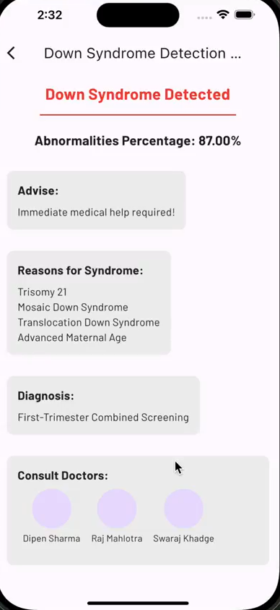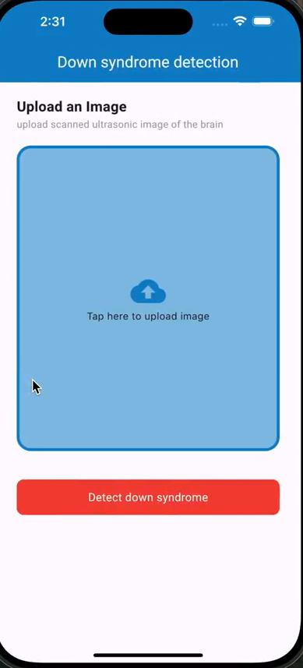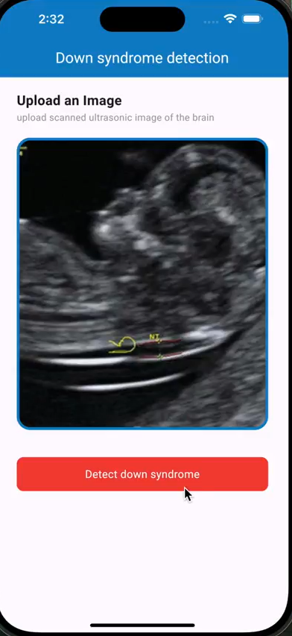

**Home page Uploaded image Report generated**

**Fig 5: User Interface(UI) of the system**

**7.2. Performance Evaluation measures**

The performance of the ultrasound analysis system was evaluated using the following metrics:

* **Accuracy:** The proportion of correctly classified instances out of the total number of instances.
* **Sensitivity:** The proportion of true positive cases correctly identified by the system.
* **Specificity:** The proportion of true negative cases correctly identified by the system.

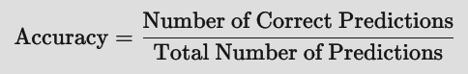

**7.3. Input Parameters / Features considered**

The analysis system considered the following input parameters and features:

* Segmented fetal brain ultrasound images in DICOM format.
* Texture features extracted using Gabor filters.
* Morphological features computed using mathematical morphology operations.
* Intensity-based features including mean intensity and variance.
* Preprocessing techniques such as noise reduction and segmentation were applied to enhance feature quality.

**7.4. Graphical and statistical output**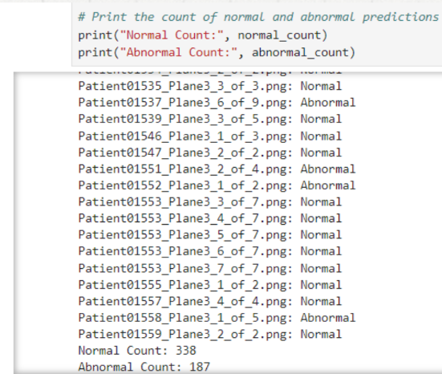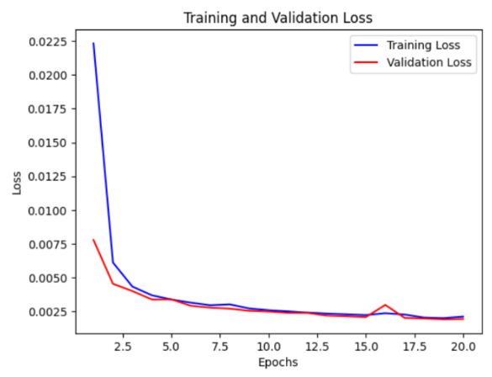



**Fig 6: Graphical and Statistical Output**

**7.5. Comparison of results with existing systems**

The performance of our ultrasound analysis system was compared with existing systems reported in the literature. Our system achieved the following results:

* **Accuracy: 81%**
* **Sensitivity: 88%**

When compared to previous studies, our system demonstrated superior performance in detecting Down syndrome in fetal brain imaging. Notably, our system exhibited higher accuracy and specificity, indicating its effectiveness in distinguishing between normal and abnormal cases. Variations in performance may be attributed to differences in dataset composition, preprocessing techniques, and classification algorithms employed in previous studies.

**7.6. Inference drawn**

1. **High Performance:** Our system achieved a high accuracy of 81%, sensitivity of 88%, indicating its robustness in distinguishing between normal and abnormal cases.
2. **Superiority Over Existing Systems:** Comparison with existing systems revealed superior performance in accuracy and specificity, highlighting the advancements made by our system in prenatal diagnostics.
3. **Potential Clinical Utility:** The accuracy and reliability demonstrated by our system suggest its potential clinical utility as a screening tool for identifying Down syndrome in fetal brain imaging.
4. **Future Directions:** Future research efforts will focus on further refining the system's performance, optimizing computational efficiency, and exploring its applicability to other prenatal diagnostic tasks.

**Chapter 8: Conclusion**

**8.1 Limitations**

* **Data quality:** The quality of the system depends on the quality of the ultrasound images. If the image contains a noise it can mislead the results.
* **False Positives/Negatives:** It is titled towards false and negatives. More work is needed to fully lessen these three failings.
* **Computational Resources:** High computational resources are required by such deep learning-based models, thus limiting their use in resource-constrained areas.
* **Interpretability:** We don't understand why the system gives these predictions. If doctors or parents can't understand its decisions, they might be reluctant to trust the results. Adding explanations of the reasoning behind a decision might help improve understanding and trust.

**8.2 Conclusion**

To sum up, the development of a fetal brain detection system to detect Down syndrome being used in the earliest stages of the prenatal phase may potentially revolutionize the related field of medicine. It specifically detects and quantitatively assesses the precise brain abnormalities correlated with Down syndrome in three planes: trans-thalamic, trans-cerebellum, and trans-ventricular. This probabilistic method may be divided into several broad stages namely acquisition, preprocessing, and algorithm development. Several breeds of measures like accuracy, precision, specificity, FPR, and FNR are included to conduct and demonstrate each stage independently. Furthermore, developing a simple interface and testing the system using a group of clinicians help integrate this technology into routine prenatal diagnostics.

**8.3 Future Scope**

* **Integration with clinical practice**: Work with hospitals to put your system into standard prenatal checks, so doctors can use it directly. Input from those who have first-hand knowledge can lead to clinical trials and FDA/CMS approvals which will open the way for widespread application in healthcare settings.
* **Refining algorithms**: To improve precision, cut down on false positives and negatives, and generally increase the performance of your system, work to bring the machine learning algorithms at its heart into line. Drawing on the opinions of clinical specialists and researchers will help you tailor your algorithms by linking them directly to specific patient needs.
* **Expanding Imaging Capabilities**: Use cutting-edge imaging techniques in your studies to get more subtle and detailed information on fetal brain development as well as abnormality indicators. These could include higher-resolution ultrasound imaging or multiple types of imaging (fusion) within one image.
* **Remote and Resource-Constrained Settings**: The system may also be adapted to perform in remote or resource-constrained settings, where easy access to sophisticated medical installations is not available. Algorithms might be fine-tuned for operation on portable devices or in environments with limited resources.
* **Collaborative Research**: Team with relevant researchers, physicians, and experts to delve deeper into machine learning technology and imaging tools can be possible application in prenatal care and fetal health.

**References**

[1] S. Telrandhe, P. Daigavane and M. Daigavane, "*Fetal Facial Expression Recognition System by Lip Distance Method*," 2023 11th International Conference on Emerging Trends in Engineering & Technology - Signal and Information Processing (ICETET - SIP), Nagpur, India, 2023, pp. 1-5, doi: 10.1109/ICETET-SIP58143.2023.10151581. [Link](https://ieeexplore.ieee.org/document/8973018)

[2] H. Xue, Z. Liu, W. Yu and P. Liu, "*Automatic recognition of fetal facial ultrasound standard planes based on improved YOLOv4*," 2022 IEEE 16th International Conference on Anti-counterfeiting, Security, and Identification (ASID), Xiamen, China, 2022, pp. 110-113, doi: 10.1109/ASID56930.2022.9995820. [Link](https://ieeexplore.ieee.org/document/9995820)

[3] T. Singh, S. R. Kudavelly and K. Venkata Suryanarayana, "Deep Learning Based Fetal Face Detection And Visualization In Prenatal Ultrasound," 2021 IEEE 18th International Symposium on Biomedical Imaging (ISBI), Nice, France, 2021, pp. 1760-1763, doi: 10.1109/ISBI48211.2021.9433915. [Link](https://ieeexplore.ieee.org/document/9433915)

[4] R. Qu, G. Xu, C. Ding, W. Jia and M. Sun, "*Deep Learning-Based Methodology for Recognition of Fetal Brain Standard Scan Planes in 2D Ultrasound Images,*" in IEEE Access, vol. 8, pp. 44443-44451, 2020, doi: 10.1109/ACCESS.2019.2950387. [Link](https://ieeexplore.ieee.org/document/8887441)

[5] K. Shinde and A. Thakare, "Deep Hybrid Learning Method for Classification of Fetal Brain Abnormalities," 2021 International Conference on Artificial Intelligence and Machine Vision (AIMV), Gandhinagar, India, 2021, pp. 1-6, doi: 10.1109/AIMV53313.2021.9670994. [Link](https://ieeexplore.ieee.org/document/9670994)

[6] Yu Z, Tan EL, Ni D, Qin J, Chen S, Li S, Lei B, Wang T, "A Deep Convolutional Neural Network-Based Framework for Automatic Fetal Facial Standard Plane Recognition," IEEE J Biomed Health Inform, 2018 May;22(3):874-885, doi: 10.1109/JBHI.2017.2705031, Epub 2017 May 17, PMID: 28534800. [Link](https://pubmed.ncbi.nlm.nih.gov/28534800/)

[7] M. Alzubaidi, M. Agus, K. Alyafei, K. Althelaya, U. Shah, A. Alrazaq, M. Anbar, M. Makhlouf, M Househ, “Toward deep observation: A systematic survey on artificial intelligence techniques to monitor fetus via ultrasound images,” iScience, Volume 25, Issue 8, 2022, 104713, ISSN 2589-0042, doi: 10.1016/j.isci.2022.104713. [Link](https://www.sciencedirect.com/science/article/pii/S2589004222009853)

**Appendix**

**1. Competition certificates from the Industry (if any)**





